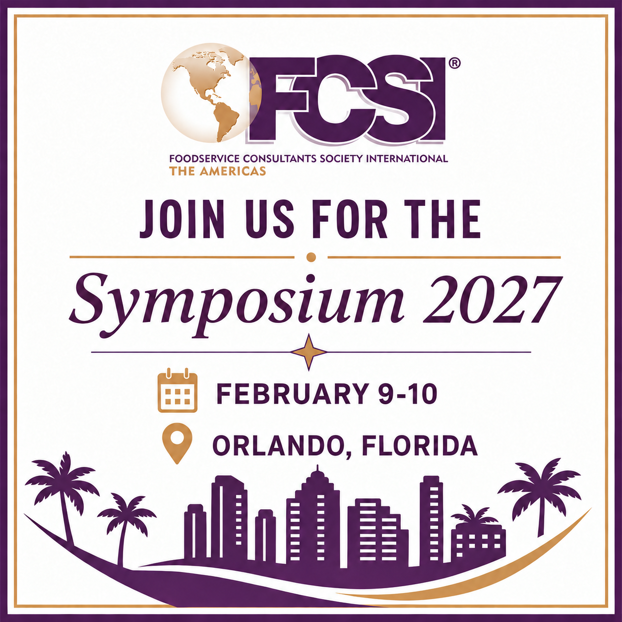

FCSI The Americas 2027 Symposium Grants
We want you to join us in Orlando before the NAFEM Show!

FCSI will be offering (10) $1000 Grants for first-time attendees of the FCSI The Americas Symposium. The intent of this grant is to encourage emerging consultants to attend the Symposium along with their principal(s) where they can expand their knowledge, extend their network, and see firsthand the value of being actively involved in FCSI The Americas.

The details:

- grants are awarded on a first come, first served basis to qualified applicants
- only one grant will be awarded per firm
- you must not have received a grant in the last four years
- grant recipients will also receive a complimentary Symposium registration
- grant recipients must attend all sessions and evening events
- grant recipients must submit a post-conference evaluation

The deadline for entries is Friday, September 25, 2026. Recipients will be notified by October 1, 2026.

Depending on where you live, the grant may or may not cover all of your lodging and transportation expenses. Only actual event expenses will be reimbursed. Any expenses over the USD$1000 grant are the responsibility of the recipient. In order to be reimbursed, grant recipients must submit their post-conference write up with their receipts.

To apply, please complete the attached application and email to Kristen@fcsi.org.

FCSI 2027 Symposium Grants
Consultant Grant Application

Name Click here to enter text.

Firm Click here to enter text.

Email Address Click here to enter text. Phone Number Click here to enter text.

Check all that apply to you:

☐ I did not attend the 2026 Conference in Phoenix

☐ I did not attend the 2025 Symposium in Atlanta

☐ I have not attended an FCSI event in the last 4 years

☐ I have never attended an FCSI The Americas Conference

☐ I have never attended an FCSI The Americas Symposium

☐ I have not received an FCSI grant in the last 4 years

☐ Associate Member ☐ Senior Associate Member ☐ Professional Member ☐ Not a Member of FCSI

Confirm that you have read and understand the following by checking off each item:

☐ The grant is a maximum of USD$1000. Any expenses that exceed the USD$1000 are the grant recipient’s responsibility
☐ Receipts may be submitted for lodging, meals, and transportation (Mileage is reimbursed at the current US government rate per mile)

☐ Grant recipients are required to submit a post-event evaluation as a condition of reimbursement

☐ Grants are awarded on a first come, first served basis to qualified applicants

The deadline for entries is September 25, 2026 · Recipients will be notified by October 1, 2026
Kristen Babiak · FCSI The Americas · 1900 E. College Ave. #A401 · Normal, Illinois 61761
kristen@fcsi.org · p: 309.808.2165 · f: 309.585.2992

